***Introduction***

In March 2020 the Government of Moldova began to mobilize a pandemic preparedness response to manage the impact of COVID-19. In order to mitigate the negative effects on the economy’s evolution, due to COVID-19, the Government has set a series of tax-related budgetary measures for supporting the business environment and established legal frameworks and transparent mechanisms for implementing the temporary tax relief to businesses to mitigate the negative fiscal impact of the COVID-19 pandemic.

The preparedness and response plan was approved by Provision no.16 of April 10, 2020 of the Commission for Exceptional Situations of the Republic of Moldova, the Law no. 60/2020 on establishing measures to support the entrepreneurial activity and amending some normative acts (further - Law no.60/2020) and the Law no. 69/2020 on the establishment of measures during the state of emergency in public health and the amendment of some normative acts (further - Law no.69/2020) the following programs were established:

|  |  |  |  |  |  |  |  |
| --- | --- | --- | --- | --- | --- | --- | --- |
|  | **Programs for direct support of entrepreneurial activity** | | | | | | |
|  |
|  | Payroll Subsidy mechanism in case of technical and/or stationary unemployment |  | Interest subsidy program | |  | | VAT refund program |
| **Subjects/**  **Beneficiaries** | Enterprises and non-commercial organizations that have established technical and/or stationary unemployment |  | | Enterprises that contracted loans between May 1 and December 31, 2020 |  | Enterprises registered as VAT taxpayers | |
| **Subsidy size** | **100%**paid payroll taxes related to allowances granted under technical or stationary unemployment for economic agents whose activity has been suspended by the Provision of the CES  **60%**paid payroll taxes) related to allowances granted under technical or stationary unemployment for economic agents whose activity has not been stopped by the Commission Provision. |  | | The amount of monthly interest paid |  | The amount of the refund is the minimum amount between:  (1) VAT amount intended for the subsequent period in the last fiscal period  (2) the amount of payroll taxes related to the month of management | |
| **Subsidy limits** | The amount of the subsidy per employee will not exceed 100% / 60% of the calculated amount of payroll taxes related to the salary payments of February 2020 per working day |  | | 1. Maximum subsidized annual interest rate**:**   8.76% in national currency and 4.40% in foreign currency   1. Maximum amount of subsidized credit   the amount of the salary fund for the September 2019 - February 2020 |  | The cumulative amount of the refund for the payment period (May 1, 2020 – December 31, 2020) will not exceed the amount of VAT for the subsequent period, reflected in the VAT return for December 2019 | |
| **Coverage period** | March 17 – May 15, 2020* and extended twice through September 30, 2020 |  | | May 1 - December 31, 2020 |  | May 1 - December 31, 2020 | |
| **Payment term** | 5 days |  | | 5 days |  | 25 days | |

*The Moldova TAMP restructuring in 2020 supported only those claims related to the period March 17-May 15, the first period of emergency (See footnote 1 of the World Bank’s Restructuring Paper REPORT NO.: RES41570, dated September 14, 2020).

Into realization of the Government’s goal in fighting with decline of economic activity, for support business survival, boost liquidity and sustain employment levels requested through the Ministry of Finance, the World Bank supports in implementing two of mentioned above subsidies programs- Payroll Subsidy mechanism in case of technical and/or stationary unemployment, and the VAT refund program.

This report summarizes results of the implementation of the mechanism for subsidizing the expenses related to the payment of salary/allowance, in case of technical unemployment and/or stationary unemployment during the state of emergency.

The Ministry of Finance, as a borrower and recipient of the Tax Administration Modernization Project (TAMP), requested the Bank to reallocate funds intended for the Project to COVID-19 mitigating activities. After the World Bank approval of the Moldova TAMP restructuration in 2020, the Bank supported the realization of the Payroll Subsidy mechanism in case of technical and/or stationary unemployment for the period March 17-May 15, the first period of emergency. That said, the actual subsidy mechanism is considered to have started only from April 30, 2020 when the requisite legal framework and applications procedures were established and ready for implementation.

*The goal of the Payroll Subsidy mechanism in case of technical and/or stationary unemployment (COVID-19)*

The mechanism aimed to support economic agents to pay salaries/allowances to employees who are technically and/or stationary unemployed, with the primary objective of maintaining the unemployment rate, respectively to keep employees at work and ensuring the mitigation of the effect of reducing budget revenues as a result of economic and financial crisis caused by the spread of COVID-19 infection and the functional dismissal of several economic sectors.

*How was the Payroll Subsidy mechanism implemented?*

The procedure and manner of mechanism implementation and respectively the subsidy requesting/granting was regulated by the Regulation on subsidizing enterprises and non-commercial organizations, residents of the Republic of Moldova, which have established technical and/or stationary unemployment as a result of the epidemiological situation (COVID-19), approved by Order no.58 of April 29, 2020 of the Ministry of Finance (further - Regulation).

( [https://www.legis.md/cautare/getResults?doc_id=121321&lang=ro](https://translate.google.com/translate?hl=ru&prev=_t&sl=ro&tl=en&u=https://www.legis.md/cautare/getResults%3Fdoc_id%3D121321%26lang%3Dro) ).

According to the Regulation, the subjects of the subsidy were enterprises and non-commercial organizations, residents of the Republic of Moldova, which have established technical and / or stationary unemployment, according to the provisions of art.80 and 801 of the Labor Code of the Republic of Moldova no.154/2003.

Subsidizing of expenses related to the payment of salaries / allowances in case of technical and/or stationary unemployment was provided in the amount of:

a. 100% paid payroll taxes (income tax, social and medical contributions paid) related to the payment of salary/allowance under technical and/or stationary unemployment for economic agents whose activity has been totally or partially stopped in accordance with the decisions of the Extraordinary National Commission for Public Health and/or the provisions of the Commission for Exceptional Situations (for example: the activity of trade, leisure, recreation units, gyms, sports centers, swimming pools, fitness rooms, theaters, cinemas, concert halls);

b. 60% payroll taxes (income tax, social and medical contributions paid) related to the payment of salary/allowance under technical and/or stationary unemployment for economic agents whose activity has been totally or partially stopped, but without being based on Commissions’ decisions.

The subsidy was paid to enterprises and non-commercial organizations (subject/beneficiaries) relative to their employees who were employed till of March 1, 2020 and then placed into technical and / or stationary unemployed status beginning the declaration of the first National Health Emergency on March 17, 2020.

The payment of the respective subsidy was made based on the application submitted by the subjects to the State Tax Service, and its granting was made within 5 working days from the date of submission, as follows:

- 3 days - for carrying out the review of received application and adopting the decision to grant the subsidy;

- one day - for the preparation of payment documents and their transmission for execution to the State Treasury;

- one day - to pay the subsidy.

***Table no. 1. The period covered by the payroll subsidy mechanism***

|  |  |  |  |  |
| --- | --- | --- | --- | --- |
| Original Period from the Declaration of the 1st state of emergency  (per Decision of the Commission for Exceptional Situations no.16/2020)- covered by the TAMP financing | 1st extension (per Law no. 69/2020 on the establishment of measures during the state of emergency in public health and the amendment of some normative acts) | 2nd extension  (per Government Decisions no.434/2020) | 3nd extension  (per Government Decisions no.575/2020) | 4th extension  (per Government Decisions no.653/2020) |
| March 17- May 15, 2020  (actually started implementation only on April 30) | May 16 - June 30, 2020 | July 1 - July 31, 2020 | August 1 - August 31, 2020 | September 1 – September 30, 2020 |

According to point 6 of the Decision of the Commission for Exceptional Situations no.16/2020, the mechanism for subsidizing the expenses related to the payment of salary/allowances was provided during the state of emergency - 60 days, until May 15, 2020. This is the period covered by the Moldova TAMP Restructuring in 2020.

The term of Subsidy mechanism was extended until June 30, 2020 by the Law no.69/2020 on the establishment of measures during the state of emergency in public health and the amendment of some normative acts, with the possibility of further extending. In this regard, according to the Government Decisions no.434/2020, no.575/2020 and no.653/2020 on the extension of the application term of the subsidy mechanism for enterprises and non-commercial organizations that have established technical and/or stationary unemployment according to the provisions of art. 80 and 801 of the Labor Code of the Republic of Moldova no.154/2003, the term of the payroll subsidy mechanism was extended until July 31, 2020, August 31, 2020 and September 30, 2020 respectively.

In this regard, the period covered by the payroll subsidy mechanism was March 17 – September 30, 2020.

Due to the extension of the subsidy mechanism duration, the applications submission period was from April 30 till November 30, 2020, with application payment period (implementation period) during April 30 –December 31, 2020 .

***Financial coverage of the payroll subsidy mechanism***

Regarding the allocation of financial resources for the implementation of the mechanism for subsidizing the expenses related to the payment of salary/allowances, by the Law no.173/2020 on amending the State Budget Law for 2020 no.172/2019, a special fund, in the amount of 100.0 million lei for subsidizing enterprises and non-commercial organizations that have established technical and/or stationary unemployment during the state of emergency and subsidizing the amount of compulsory state social insurance contributions in a fixed amount, was established.

As it was mentioned above, the payroll subsidy mechanism’s implementation during the state of emergency - 60 days, until May 15, 2020 was financed by the World Bank’s TAMP.

**Table no. 2. Information related to the payroll subsidy mechanism implementation for the period March 17 – May 15, 2020**



Thus, 446 economic agents submitted 1 241 applications requesting subsidies for the total amount of 61 133 070,01 lei for the period from March 17 – May 15, 2020.

Out of total applications submitted to the State Tax Service (STS), 944 applications corresponding to 413 applicants were approved for subsidies’ payment in the total amount of 49 460 981.29lei.

Following the STS’s quality control, 176 applications in the total amount of 6 616 904,13 lei have been rejected. Also, 85 applicants have been withdrawn by applicants due to the revealed mistakes in submitted information or non-eligibility aspects.

The key reasons of applications’ withdrawn were:

- the economic operator requested the subsidy for 100% during the control, but it was attested that it he fell under the subsidy category 60%;

- the incorrect calculations’ reflection in the information submitted to STS;

- the partial payment of taxes, etc.

The total subsidies amount approved for payment was 11 672 088,77 lei less of originally requested.

Thus, 93 % of applicants received subsidies and 76 % of total received applications were paid in accordance with the eligibility requirements defined by the Order No.58 of April 29, 2020 of the Ministry of Finance.

**Table no. 3 Accepted subsidies for the March 17 - May 15, 2020 period (separately for each month)**

|  |  |  |  |
| --- | --- | --- | --- |
| **Period** | **Amount of subsidies accepted for other categories of enterprises, lei** | **Amount of subsidies accepted for large enterprises, lei** | **Total amount, lei** |
| ***March*** | 2,913,603.68 | 5,040,069.07 | 7,953,672.75 |
| ***April*** | 6,146,958.96 | 22,713,398.57 | 28,860,357.53 |
| ***May*** | 3,895,547.29 | 8,751,403.72 | 12,646,951.01 |
| ***Total*** | **12,956 109.93** | **36 504 871.36** | **49,460,981.29** |

The information related to the payroll subsidy mechanism implementation covering its overall period from March 17 until September 30, 2020 and executed through December 31, 2020 is presented below.

**Table no.4 Information related to the implementation of mechanism during the whole period**



For the whole period covered by payroll subsidy program (including period for applications’ submission from April 30 to November 30) 474 enterprises submitted 1 628 applications requesting subsidies for the total amount of 88 518 181.79 lei.

 Out of total applications submitted to the State Tax Service, 1147 applications corresponding to 415 applicants were approved for subsidies’ payment in the total amount of 59 214 298, 11 lei. Following the STS’s quality control, 303 applications in the total amount of 20 526 069.06 lei have been rejected. Also, 148 applicants have been withdrawn by applicants due to the revealed mistakes in submitted information or non-eligibility aspects.

Thus, 86 % of applicants received subsidies and 70 % of total received applications were paid in accordance with the eligibility requirements defined by the Order No.58 of April 29, 2020 of the Ministry of Finance. As a result of the control carried out by the State Tax Service the difference between the requested amount of subsidies and paid totaled 29 303 883,68 lei.

The largest subsidy amounts were paid in June - July 2020 in the amount of 15.392.783,95 lei and 14.135.829,62 lei respectively.

*Figure no. 2* -*Subsidies amounts paid by month (in lei)*

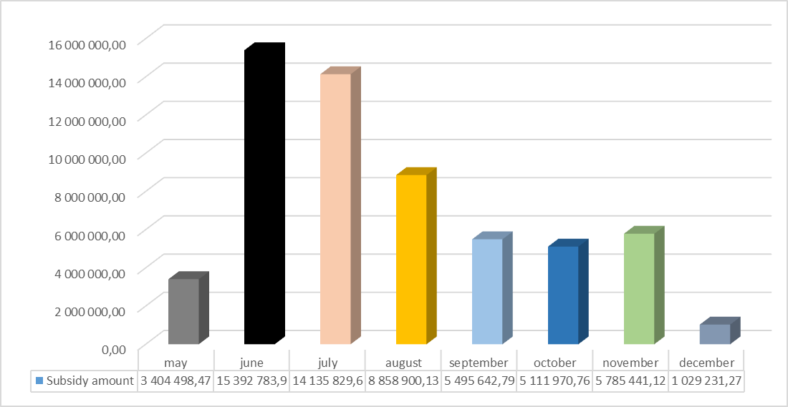

The micro and small enterprises represented the largest share group of beneficiaries for the subsidy program among different types of enterprises.

*Figure no.3 - Beneficiaries of subsidies by size of the enterprises* (in terms of no. of applicants)*

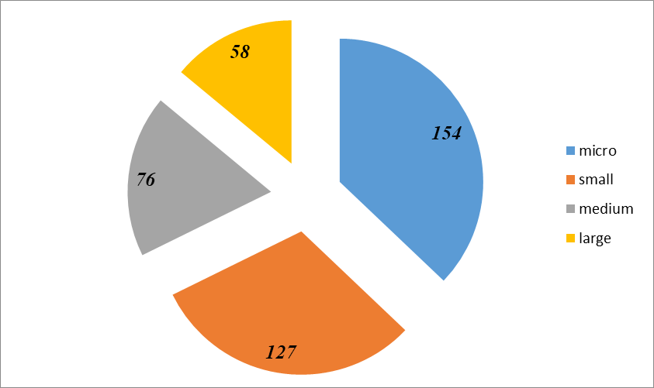

*\*Classification of enterprises by size is based on Art.5 of the Law on small and medium enterprises no. 179 of 21.07.2016:*

*micro enterprise – enterprise with a total of 9 employees;*

*small enterprise – enterprise that has from 10 to 49 employees;*

*medium-sized enterprise – an enterprise that has from 50 to 249 employees;*

*large enterprise - has more than 250 employees.*

Respectively, from the total number of enterprises (415 economic agents) that applied and were confirmed as beneficiaries for a subsidy to cover salary expenses in case of technical and/or stationary unemployment, 281 enterprises (or 67.7%) represented the micro and small enterprises.

It is obvious that in the situation of the deep economic-financial crisis that the Republic of Moldova is facing, the most affected segment was of SMEs. Micro, small and medium-sized enterprises have been more sensitive to economic disturbances, in contrast to large companies that have registered small economic deviations whether due to easy adaptation or due to specific activity of the economic sector in which they operate.

However, the value share of the subsidy amount paid to large enterprises cumulatively exceeds the amount of subsidies paid to the SME segment as Figure 4 below shows.

***Figure no.4 - Total amount of subsidy paid by type of enterprise***

Based on the data presented, it can be seen:

* for 154 micro enterprises, the amount of 1.420.767 lei was paid;
* for 127 small enterprises the amount of 5.023.454 lei was paid;
* for 76 medium-sized enterprises the amount of 9.130.134 lei was paid;
* for 58 large enterprises, the amount of 43.639.943 lei was paid.

About 74% of all subsidies amount was paid to large enterprises representing 13,7% of all beneficiaries, while micro and small businesses (67,7% of beneficiaries) received about 11% of total subsidies amount.

The economic impact of the crisis caused by COVID-19 varied from one industrial sector to another. Applications for subsidy granting to cover salary expenses during the state of emergency and state of emergency in public health were requested by 415 enterprises in 18 economic sectors, which account about 8.5% of the total number of employees in the real sector.

***Figure no.5 - Number of subsidy beneficiaries by economic activity***

*A - agriculture, forestry and fishing; C - manufacturing industry; D - production and supply of electricity and heat, gas, hot water and air conditioning; E - water distribution; sanitation, waste management, decontamination activities; F - constructions; G - wholesale and retail trade; maintenance and repair of motor vehicles and motorcycles; H - transport and storage; I - accommodation and public catering activities; J - information and communications; K - financial and insurance activities; L - real estate transactions; M - professional, scientific and technical activities; N - administrative service activities and support service activities; P - education; Q - health and social assistance; R - art, recreation and leisure activities; S - Other service activities, Other.*

Thus, according to the data presented above, the largest share of beneficiaries (26,7% or 111 enterprises) operate in the field of wholesale and retail trade. The amount of 6.748.526,03 lei (or 11,4%) was granted to enterprises in the respective sector.

The second place took the manufacturing industry with 60 beneficiaries and the third one was for accommodation and catering activities (28 beneficiaries), where subsidies were granted in the amount of 20.514.966,06 lei and 2.900.165,27 lei respectively. The smallest number of beneficiaries were from water distribution, sanitation, waste management and decontamination activities, as well as agriculture, forestry and fishing sectors.

While the manufacturing sector is the second by the number of subsidy beneficiaries, but it is the first by the total amount of subsidies granted (34,6%). The second largest share of subsidies was granted to enterprises of Transport and storage sector (16%), and 11,4% of the total amount was granted to the wholesale and retail trade.

Detailed information on the financial support enterprises obtained as a result of their participating in the subsidy mechanism for covering salary expenses in case of technical and/or stationary unemployment is presented in Table 4.

***Table no.5 - Total amount of subsidy paid to each sector affected by COVID-19 (as per Classification of Activities in the Moldovan Economy)***

|  |  |  |  |  |  |  |  |
| --- | --- | --- | --- | --- | --- | --- | --- |
| **SECTION** | **No. of beneficiary enterprises** | **Total paid amount (lei)** | **Percentage of total paid subsidy amount** | **No. of employees in April 2020** | **No. of employees in December 2020** | **Percentage deviation of the number of employees** | **No. of active enterprises in December 2020\*** |
| **C - manufacturing industry** | 60 | 20,514,966.06 | 34.65% | 26009 | 24456 | -5.97% | 59 |
| **H - transport and storage** | 12 | 9,489,052.70 | 16.02% | 8344 | 8048 | -3.55% | 12 |
| **G - wholesale and retail trade; maintenance and repair of motor vehicles and motorcycles** | 111 | 6,748,526.03 | 11.40% | 4711 | 5107 | 8.41% | 110 |
| **D -production and supply of electricity and heat, gas,  hot water and air conditioning** | 17 | 5,306,840.74 | 8.96% | 8582 | 8666 | 0.98% | 17 |
| **I - accommodation and public catering activities** | 28 | 2,900,165.27 | 4.90% | 1250 | 1067 | -14.64% | 24 |
| **P - education** | 12 | 2,354,449.72 | 3.98% | 638 | 696 | 9.09% | 12 |
| **R - art, recreation and leisure activities** | 11 | 2,069,921.14 | 3.50% | 882 | 902 | 2.27% | 11 |
| **E - water distribution; sanitation, waste management, decontamination activities** | 3 | 1,920,719.47 | 3.24% | 2027 | 2084 | 2.81% | 3 |
| **K - financial and insurance activities** | 18 | 1,887,903.02 | 3.19% | 5447 | 6162 | 13.13% | 17 |
| **N- administrative service activities and support service activities** | 25 | 1,399,605.98 | 2.36% | 665 | 605 | -9.02% | 22 |
| **S - other service activities** | 17 | 1,209,616.66 | 2.04% | 246 | 299 | 21.54% | 15 |
| **J - information and communications** | 8 | 1,051,960.01 | 1.78% | 1298 | 1299 | 0.08% | 7 |
| **Q - health and social assistance** | 21 | 829,182.13 | 1.40% | 846 | 1244 | 47.04% | 19 |
| **Other** | 21 | 508,717.00 | 0.86% | 190 | 288 | 51.58% | 20 |
| **M - professional, scientific and technical activities** | 17 | 343,381.83 | 0.58% | 200 | 217 | 8.50% | 17 |
| **L - real estate transactions** | 17 | 321,007.15 | 0.54% | 313 | 339 | 8.31% | 17 |
| **F - construction** | 12 | 299,806.34 | 0.51% | 1133 | 1184 | 4.50% | 12 |
| **A - agriculture , forestry and fishing** | 5 | 58,476.86 | 0.10% | 152 | 156 | 2.63% | 5 |
| **Total** | **415** | **59,214,298.11** | **100** | **62933** | **62819** | **-0.18%** | **399** |
| * no. of firms still operating in April vs December | | | | | | | |

In order to identify the impact of COVID-19 imposed restrictions on business continuity in different economic sectors, a comparative analysis on the number of employees (April-December 2020) in those sectors was carried out.

***Figure 6 - Number of enterprises with changed number of employees by sector during the period April 30 –December 31, 2020***

As a result of the comparative analysis, during the payroll subsidy implementation period April - December 2020, it is observed:

* 177 enterprises from all affected economic sectors increased the number of employees, by 3433 employees.
* 238 economic agents decreased their number, by 3547 employees.

Respectively, 42.9% of economic agents increased the number of working place, and 57.1% registered a lower number of employees in December compared to April 2020.

The trend related to the increase in the number of employees is found for economic agents from sector D - production and supply of electricity and heat, gas, hot water and air conditioning, F- construction, L- real estate transactions, Q - health and social assistance, R - art, recreation and leisure activities. The higher decrease in the number of employees is found for economic agents from sector G - wholesale and retail trade; maintenance and repair of motor vehicles and motorcycles; C - manufacturing industry and I - accommodation and public catering activities.

***Figure 7 - Number of employees in beneficiary enterprises by month (April-December 2020)***

As Figure 7 shows quite stable employment during the period of payroll subsidies program implementation. The number of employees at the end of December was almost similar to that of in April 2020. The lowest level was observed only in August 2020 that could be explained by uncertainty and unpredictability of business reactions to the effects of the COVID-19.

***Grievance mechanism***

The procedure of grievance mechanism took place in accordance with the provisions of Chapter 17 of the Fiscal Code "Appeals".

Thus, according to the provisions of art. 268 of the Fiscal Code, the appeal against the decision of the State Fiscal Service or the action of the tax official shall be submitted within 30 days from the date of receipt of the decision or undertaking of the contested action. In case of omission of this term for justified reasons, it may be re-established, at the request of the person concerned in the decision or against which the action was taken, by the State Tax Service.

According to the provisions of art.270 paragraph (2) of the Tax Code, the taxpayer is invited to examine the appeal, in accordance with art.226 paragraph (1), (2) and paragraph (3) letters a) -e), to give explanations, having the right to submit confirmatory documents, and according to par. (3), after the examination, a decision is issued on the appeal, a copy of which is handed over or sent, recommended, to the taxpayer within 3 working days after the issuance of the decision.

In case of disagreement with the issued decision, according to art.274 of the Fiscal Code, the taxpayer is entitled to challenge the decision of the STS and the actions of the fiscal officials, in the manner established by the legislation, in court.

During the May-December 2020, 9 appeals were received and examined in a total amount of 86224 lei, from 5 taxpayers, who carry out their activity in the following fields: broadcasting the television program service; wholesale of goods; construction of engineering and civil buildings; insurance / reinsurance; the cultivation of cereals, legumes, oil plants. The STS, following the examination of the appeals received, rejected all of them (with 8 decisions issued) caused by the non-fulfillment of the necessary conditions for subsidy.

***Conclusion***

Overall, the implementation of payroll subsidies mechanism has succeeded in minimizing the shock on the labor market caused by COVID-19 pandemic. The Government, achieved its objective as emergency measure to ensure business survival and sustain employment in the context of COVID-19 pandemic. The implementation of payroll subsidy mechanism over-achieved its target outcomes of 75% of beneficiary companies that received subsidies under the payroll subsidy mechanisms continued operation and maintained employment at 60% level compared to April 2020.

As of 31 December 2020, 399 enterprises which represent 96% of beneficiaries continued to operate and maintained an employment level of 99,8% in December 2020 compared to April 2020.